how to use endnote
USER GUIDE FOR BEGINNERS

Contents
What is EndNote? 3
1. Getting Started with EndNote 3
2. Adding References 3
3. Organizing Your References 4
4. Citing References in Microsoft Word 5
5. Managing Bibliographies 6
6. Backing Up and Syncing 6
7. Troubleshooting Common Issues 7

What is EndNote?
EndNote is a tool that creates, stores and manages references and bibliographies.
EndNote Desktop allows you to:
- Import selected references to your EndNote library from various online search tools (e.g. LibrarySearch, library databases and Google Scholar).
- Manually create references in your EndNote library.
- Insert references from your EndNote library into your Microsoft Word document (Cite While You Write (CWYW)).
- Attach full-text PDFs to your references.
- Organise references into groups.
- Share your EndNote library/groups with other EndNote users.

1. Getting Started with EndNote
- Installation: Download and install EndNote from EndNote's official website or through your institution if it provides a license.
- Setting Up Your Library: Open EndNote and create a new library by selecting File > New. Save your library in a secure location, as this will store all your references.
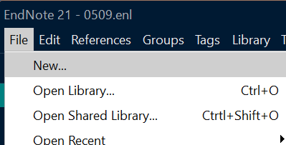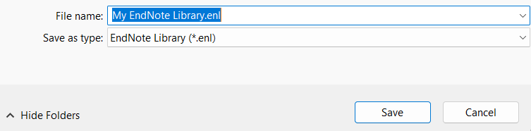

2. Adding References
- Manual Entry: Click References > New Reference OR click on the right of the toolbar towards the top.
- The default setting for new references is Journal Article .
- If you are using something else, you can change the reference type within the Reference Type drop-down list, e.g. Book, Book Section [for book chapters in edited books], Conference Paper, Web Page, etc.
- Fill in fields such as author, title, year, and source. Then, File > Save or press Save button on the top right corner
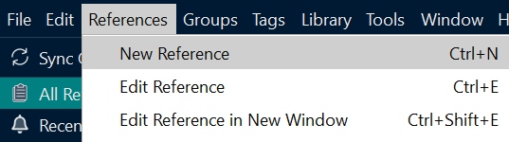
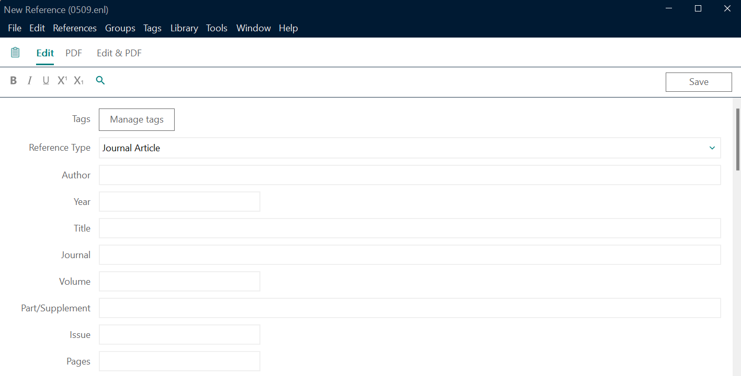
- Importing from Databases: Many academic databases, such as Google Scholar or PubMed, offer options to export citations directly to EndNote. Select the Export or Cite option in the database, and download the file. Then, open EndNote and go to File > Import to upload the citation file.

3. Organizing Your References
- Creating Groups: Right-click on My Library and select Create Group to organize references by topic, project, or type.
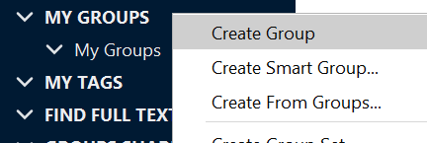
- Sorting and Searching: Use the search bar at the top to locate specific references. You can also sort references by author, year, title, or any custom field.

4. Citing References in Microsoft Word
- EndNote Plugin: Ensure you have the EndNote plugin installed in Word. This should appear as the EndNote tab in your Word toolbar.
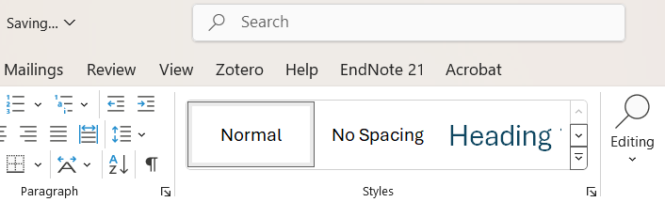
- Inserting Citations: Place your cursor where you want to insert a citation, go to the EndNote tab, and select Insert Citation. You can search for a reference by keyword or author name.
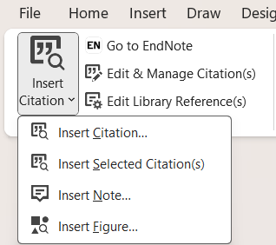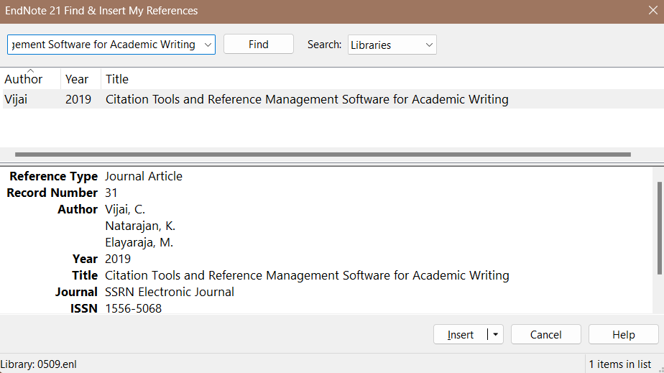
- Formatting Citations and Bibliographies: Choose a citation style under EndNote > Style. You can switch styles as needed (e.g., APA, MLA, Chicago).
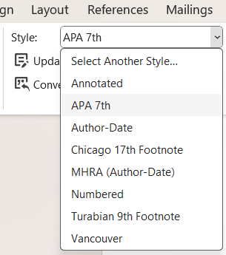
- Editing Citations: Select Edit & Manage Citation(s) in the EndNote toolbar in Word to modify in-text citations, remove author names, or add page numbers.
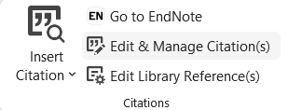

5. Managing Bibliographies
- Automatic Bibliography: EndNote automatically creates a bibliography at the end of your Word document based on the references cited.
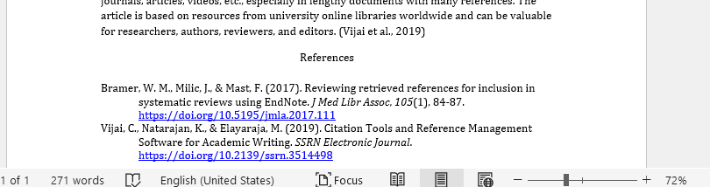
- Customizing the Bibliography Format: You can adjust the font, size, and line spacing by going to EndNote > Configure Bibliography in Word.

6. Backing Up and Syncing
- Syncing with EndNote Online: Go to Edit > Preferences > Sync in EndNote to sync your library with EndNote Online, allowing access across multiple devices.
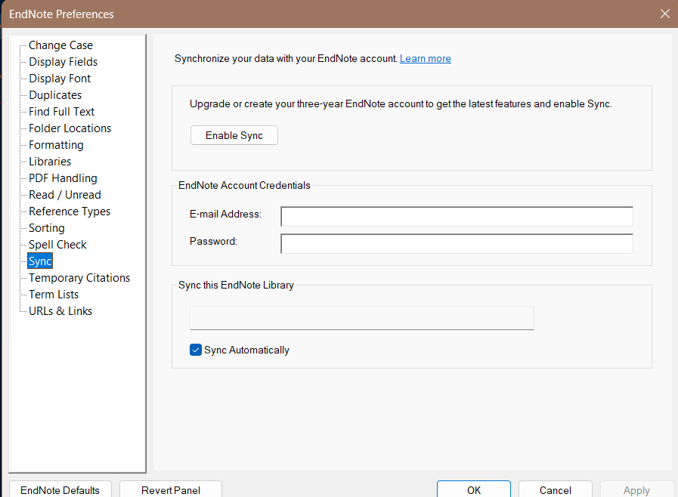
- Creating Backups: Regularly back up your EndNote library by saving a copy of the .enl file and the associated .Data folder.

7. Troubleshooting Common Issues
- Missing EndNote Tab in Word: If the EndNote tab doesn’t appear in Word, reinstall the EndNote plugin by going to EndNote Help > Customer Support or reinstalling EndNote.
- Duplicate References: Use References > Find Duplicates to remove duplicate entries in your library.
- Incorrect Citation Style Formatting: Verify that the citation style selected matches your document requirements and that updates are installed.

